EYE & DUNSDEN PARISH COUNCIL
Minutes of a Meeting held on April 18th 2023 at 7.45pm at Dunsden Hall

Present: Cllrs David Woodward, Ian Pringle, Richard Berkley, Clive Leeke, David Bartholomew (OCC + SODC) and Leigh Rawlins (SODC).
Two Councillors did not seek re-election to the Parish Council. Clive Leeke was thanked for his contribution over the last 4 years. He said he was still willing to give advice over trees and green issues. He was thanked for this.
New Councillors are being sought. Suzanne Abraham has been nominated.
038/23 Apologies for absence Naomi Baylis,
039/23 Declarations of interest No new declarations.
040/23 Minutes of the last meetings The Chairman proposed that the minutes of February 21st 2023 were accepted as a true record. This was seconded by Ian Pringle.
041/23 Matters arising from the minutes
026/23 Emergency Planning: A Flooding Emergency Plan has already been written but further work is necessary. The requested survey was completed and returned by the Clerk. The Village Hall is the ideal place for an emergency venue and the Village Hall committee may apply for a grant for this. The Clerk will forward a copy of the plan to the Committee for perusal. (Clerk to action)
042/23 County Councillor's report Cllr Bartholomew summarised his local reports. The full report will be attached to the minutes. Cosmonaut Leisure was discussed and Tarmac are taking legal advice over the tenancy.
043/23 District Councillor’s Report Cllr Rawlins summarised his report which is attached to these minutes.
044/23 Public Question Time/Correspondence A complaint about South Rd was made. The French Horn has expressed concern over the Furleigh Car Park. The Clerk is contacting Security Car Parking Firms. (Clerk to action)
045/23 Financial Position
045.01/23 The present financial situation had been previously circulated.
045.02/23 The April 2023 accounts were presented and the accounts for the March meeting that had to be cancelled (£1,998.46). Those and the April invoices to the value of £4,186.13 were authorised for payment. These payments were proposed by Ian Pringle and seconded by Richard Berkley. All agreed. (Clerk to action)
045.03/23 The Clerk had forwarded the annual accounts on an Excel file for the year ending March 31st 2023 to all Councillors for information prior to submission to the internal auditor. The figures were agreed. (Clerk to action)
045.04/23. The Joint Parish Action Group funds are being held in the EDPC account. Costs need to be paid by EDPC initially and claimed back from the members of JPAG that was set up to submit the report to Natural England. The Clerk was asked to request the sum of the grant received by Kidmore End PC so that the funds could be kept together. The Clerk was also asked to invoice the 6 PC’s for half of the amounts agreed to contribute to the group again to keep the funds together. (Clerk to action)
046/23 Planning Matters
New Applications
P23/S0542/FUL Erection of a substation, 6 ultra-rapid rapid electric vehicle chargers and associated equipment in the car park. Playhatch Garden Centre Henley Road Playhatch RG4 9RB. The PC recommended this application for approval.
Consultation concluded
Scoping Opinion for: Scoping Opinion request in support of a planning application for a southern and eastern extension to Sonning Quarry, using existing consented ancillary facilities including site access points onto Playhatch Road, the A4155, together with retention and operation of plant site situated south of Playhatch Road along with retention and use of field conveyor including bridges over Playhatch Road and Spring Lane, with restoration using indigenous and import materials to agricultural land and nature conservation habitat at Sonning Quarry, Playhatch Road, Sonning Eye, Reading, RG4 6TX Response made.
047/23 Eye & Dunsden Village Hall A list of classes and a wedding brochure is now available. Funds are now being sought to replace the tiled roof.
048/23 Community Orchard Clive Leeke will ask Greg to look at the leaning tree on the LHS of the orchard.
049/23 Neighbourhood Development Plan David Woodward has had to resign from the chairmanship of the group due to pressure of work. The project plan is moving towards the Regulation 14 Consultation sometime in the Summer.
050/23 Joint parishes AONB Group The group should have evidence by mid-May.
See also under 045.04/23 for finances.
051/23 Highways, Footpaths & Open Spaces
051.01/23 Playhatch permissive path request. Richard Berkley will speak to Adrian Beales.
(Vice Chairman to action)
051.02/23 Potential TPO’s. This could be considered after the NP has completed.
051.03/23 Sonning Boats. The Environment Agency are now monitoring the situation regarding pontoons and have met the operators. The Chairman has also had a conversation with an Enforcement Officer.
051.04/23 Furleigh Car Park. The Clerk was asked to contact Dexter & Montague Solicitors regarding the registry of the Furleigh Car Park that it has maintained for many years.
051.05/23 South Rd. The state of the road has been reported. The Clerk was asked to request that Cllr Bartholomew pursue this for the PC. (Clerk to action) The Clerk was also asked to request that Cllr Bartholomew escalate the clearing of all the blocked gullies from the Sonning Bridge traffic lights to the Sonning Eye roundabout. (Clerk to action)
052/23 Allotments A pile of rubbish has accumulated at the end of the allotments. The tenants have been asked again to remove it.
053/23 Website The work to be done on the website is in hand.
054/23 Minerals/Playhatch & Sonning pit Liaison Groups. The French Drain is being inspected by Grabloader but it is necessary for Highways to clear the drain under the Playhatch roundabout regularly. The Clerk was asked to contact OCC to request all the drains in Playhatch from the top to the roundabout as all are blocked. The recent rain caused flooding and a major hazard as all the drain covers raised up and this was a safety concern for vehicles. (Clerk to action) Richard Berkley will also speak to Chris Dance about the amount of gravel that runs down into Playhatch with the rain. (Vice Chairman to action)
055/23 Coronation. Residents of Eye & Dunsden are invited to the Binfield Heath Coronation lunch.
056/23 Conservation Area This is being considered and a map has been forwarded to the Officer. It was thought that this could be something that could be tackled from the Neighbourhood Planning Group a bit later as the process takes 18 months.
057/23 Matters for future consideration Potential TPO’s; New Conservation Areas

Next meeting: May 16th 2023

REPORT TO EYE & DUNSDEN PARISH COUNCIL APRIL 2023

FROM CLLR DAVID BARTHOLOMEW
GENERAL OCC REPORT

HOME TO SCHOOL TRANSPORT SPARE SEATS SCHEME CANCELLATION

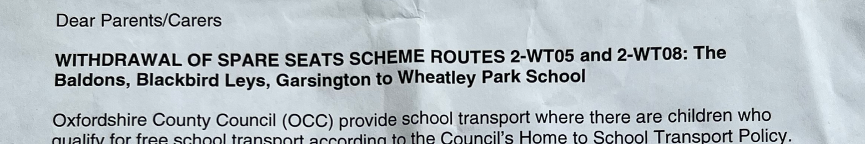

Prior to the Full Council meeting on 14 February, councillors were bombarded with emails from concerned parents and pupils alarmed by the administration’s decision to withdraw the ‘Home To School Spare Seats Scheme’ in certain areas. At the Full Council meeting on 28 March, many concerned parents spoke passionately against the proposals. The Conservative Opposition then moved a motion containing the words “This Council apologises unreservedly for its decision to send ‘withdrawal’ letters to parents under its Spare Seats scheme without parental or wider public consultation. The wording of its withdrawal letters caused significant anxiety and distress to parents in predominantly rural areas, with up to 235 children affected in the short term and as many as 1,384 students in the medium term.” The administration voted down the wording and passed a diluted motion, which Conservatives voted against.

OXFORD TRAFFIC FILTERS (THE FOUR SECTOR PLAN) MOTION

At the same council meeting, concerned residents and businesses had earlier spoken against the ‘Traffic Filter’ scheme that will divide Oxford into four sectors for traffic purposes, and questioned the consultation process. Conservatives then moved a motion to re-run the consultation but were voted down by the administration.

COST OF OCC’S COUNTY HALL CAR PARK REPAIRS

OCC has spent around £15,000 repairing the County Hall carpark. Shadow Cabinet Member for Highways Liam Walker said: “I think residents will be frustrated as to why the car park outside county hall has been resurfaced whilst roads across Oxfordshire best resemble the surface of the moon in places. It’s yet again clear that the coalition’s focus is in the wrong place. They waste funds on projects like this, which could have fixed nearly 300 potholes instead.” | 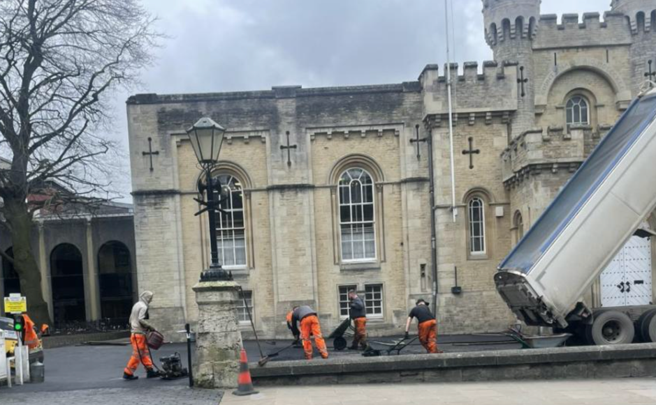

OXFORDSHIRE AWARDED £6.4M TO TACKLE ENERGY INEFFICIENCY
Hundreds of Oxfordshire households struggling with fuel poverty will benefit from energy efficiency improvements after the county was awarded £6.417 million by the government. The Home Upgrade Grant (HUG2) funding will deliver whole-house retrofit installations to at least 310 properties across Oxfordshire that are not heated by mains gas – instead heated, for example, by electricity, liquefied petroleum gas, coal or oil.

OXFORD ZEZ ANNIVERSARY: OCC RAKES IN £700K FROM TRAFFIC SCHEME
A scheme which charges motorists to drive through the city in an attempt to reduce emissions has raised almost £700,000 in fines in the year since it was launched. Britain’s first Zero Emission Zone (ZEZ) began in Oxford in February 2022. The pilot scheme covers just a handful of city centre streets. Vehicles are charged between £2 and £10 per day depending on their emissions. There are discounts and exemptions for some road users. Zero emission vehicles, such as electric cars, can enter the pilot area free of charge. Initially warning notices were issued to drivers but from April 2022 OCC started handing out fines. Given the amount of money raised, critics are saying that the scheme has failed as a ZEZ, but succeeded as a cash generator. Controversial proposals are now being developed to extend the ZEZ to a wider area of the city. These measures are on top of the controversial Low Traffic Neighbourhoods (LTNs) and the even more controversial ‘Traffic Filter’ proposals that will split Oxford into four sectors for cars without a permit.

HOUSEHOLD WASTE RECYCLING CENTRES: SET FOR REFRESH IN MARCH AND APRIL
People planning to visit Household Waste Recycling Centres (HWRCs) during March and April are being warned about a series of short closures to enable deep cleaning and essential maintenance to take place. This includes jet washing the sites and structures, repainting lines and safety areas, as well as other general work to improve the customer experience. The closing dates are:
- Alkerton, near Banbury: Monday 20 and Tuesday 21 March
- Ardley, near Bicester: Thursday 23 and Friday 24 March
- Dix Pit, Stanton Harcourt: Monday 24 and Tuesday 25 April
- Drayton, near Abingdon: Thursday 30 and Friday 31 March
- Oakley Wood, near Wallingford: Thursday 20 and Friday 21 April
- Redbridge, Oxford: Monday 17 and Tuesday 18 April
- Stanford, near Farringdon: Monday 27 and Tuesday 28 March.
More information can be found on OCC’s website, including details of nearest alternative sites during the closures.

HOUSEHOLD WASTE RECYCLING CENTRES: DIY WASTE PRICES TO RISE
The cost to customers of disposing of DIY and other chargeable waste at HWRCs will rise this month. While most items brought to OCC’s seven HWRCs can be left free of charge, DIY waste – items such as rubble, soil, fence panels, work tops and sinks – is legally classified as industrial waste and incurs a charge. From 1 April, all items currently charged at £1.50 will now cost £2. This covers most waste generated through home and garden renovations, including loft insultation, guttering, decking and fitted furniture. A list is available on the council’s website. The cost of disposing of bags of plasterboard will rise from £2.50 to £3.50, tyres from £5 to £6, but plasterboard sheets will remain at £10. Cash is not accepted, so visitors have to pay electronically before travelling. People who are unable to pay for items will not be permitted to deposit them. The Conservative Opposition is deeply concerned these measures will lead to an increase in fly tipping and will also present payment problems for those who do not have electronic payment facilities – contrary to OCC’s ‘Digital Exclusion’ policy.

SPECIFIC OCC REPORT FOR EYE & DUNSDEN
SONNING QUARRY LIAISON COMMITTEE
The committee met on Thursday 13th April. There were no immediate concerns although there is some apprehension about future expansion plans for the site. The E&D PC Chair and Vice-chair were in attendance.

FMS: ENQ23945697/ENQ23945692/ENQ23942696 ACCIDENT DAMAGE AT SPAN HILL
The chevrons have now been repaired/replaced and the accident debris cleared.

FMS ENQ23947486: FAILED ROAD REPAIR AT SPAN HILL
I received a number of emails about these potholes during the early part of the year. They have now been repaired.

GENERAL SODC REPORT
SODC BUDGET AND HQ MOVE

On 16 February, the Conservative Opposition voted against the administration’s Budget principally on the grounds it could not support the £25M of Council Tax payers’ money being wasted on an unnecessary new HQ in Didcot.

SPECIFIC SODC REPORT FOR EYE & DUNSDEN
P22/S1691/FUL CHANGE OF USE OF CAVERSHAM LAKES

On 02 March, SODC served two enforcement notices on all persons known to have an interest in Caversham Lakes.
Notice A - requires the use of the land for water-based sport and recreation to stop, together with all ancillary activities; and to remove from the land all facilitating development.
Notice B - requires all building, engineering and other operations to be removed from the land; and the land to be restored to its previous condition.
Both notices were due to take effect on 12th April 2023 unless appeals were submitted to the Planning Inspectorate before that date, in which event the terms of the notices will be suspended pending the outcome of those appeals. Once the notices do take effect, however, the owner/occupier will have 4 months in which to comply with Notice A and 9 months in which to comply with Notice B.

CAVERSHAM LAKES LANDLORD/TENANT ISSUES

Tarmac issued a statement on the matter and E&D PC has been provided with a copy.

SODC ward councillor’s report Eye & Dunsden – 18th April 2023
Covid-19
The reliability of data on Covid cases is now much reduced following the end of test and trace. However national figures have shown falls in cases – contrary to what might be expected for this time of year. At 8th April 2023, reported cases in SODC were at a weekly rate per 100k of population of 48 (it peaked at 1,504 on 6th January 2022) – a very low level - albeit that reporting may be somewhat incomplete. (Anecdotally I hear a lot of people saying that they, family or friends have (or have recently had) Covid – but that doesn’t seem to get reflected in the published data? Many don’t report it.) Separately, there has been significant levels of flu causing some references to a “twindemic” in terms of absences and pressures on the NHS. (Such pressures are also, of course, complicated now by pay disputes.)

Housing Mix – Census 2021 data
Results from the early release of univariate data from the census 2021 show some shocking facts in South Oxfordshire. They show that of the increase and change in housing stock between 2011 and 2021 fully 46% of the change is made up of 4+ Bedroom homes. We do not yet have the multivariate reports which will come later in the Spring. They will breakdown changes in market and social housing. However by using the early release of tenure data it is now clear that of the change in market housing the 4+ bedroom mix was so great that the mix of 1-3 bedroom homes – which was supposed per the 2014 SHMA to be 76% was actually less than half that. Some estimates have to be made at this stage because hybrid (shared ownership) social units get included with market under-mortgage data in the initial census release. In important part this problem has been caused by a large volume of extensions and Permitted Developments that have reduced the stock of 1-3 bedroom homes and increased the stock of 4+ bedroom homes. That is a bit like cutting the lower rungs from the housing “ladder” and moving then up – making them inaccessible for many first-time buyers etc. The only thing that can be done is to minimise the number of new-build 4+ bedroom homes – both on allocated sites and infill. Clearly the lack of supply of 1-3 bedroom homes locally is likely to have pushed up market prices and rents. Social rents are set by reference to a set % of market rents. The other effect is to make access to more modest housing difficult for the local young and less affluent. Instead in effect excess supply of 4+ bedroom units within the housing stock draws in discretionary demand from outside the district; responding to marketing. I repeat this because I think it is a really important issue and should inform us all going forwards.

AONB extension
Due to illness at our contractor, the next meeting was deferred from 15th March to18th April 2023.

District elections in May and Voter ID
The district elections will be held on Thursday 4th May. Just a reminder again that they will be the first elections in which the new and more bureaucratic “Voter ID” requirements will be in place. Although there is virtually no past evidence of impersonation when voting, voters will now be required to produce photographic ID from a nominated range of options. (This range of options are far more restrictive for younger voters.) However those seeking a postal vote can apply without photo ID and also vote by post without it. Those without photo ID can apply to obtain a “voter ID certificate” by making an application.
Please see link for details :- https://www.southoxon.gov.uk/south-oxfordshire-district-council/local-democracy-and-elections/elections-and-voting/new-for-2023-you-will-need-to-show-photo-id-when-voting-at-a-polling-station/ It would be helpful to publicise this change to minimise any reduction of turnout.

Leigh Rawlins
District Councillor

