EYE & DUNSDEN PARISH COUNCIL
A Meeting of the Council will be held on November 15th 2022 at Dunsden Village Hall commencing at 7.45pm.
- Apologies for absence
- Declarations of Interest
- Minutes of the Parish Council meeting held on Tuesday October 25th 2022
- Matters arising from the minutes
- County Councillor’s report
- District Councillor’s report
- Public Question Time/Correspondence
- Financial Position: a) Accounts b) November accounts for payment c) Budget for 2023;
- Planning Applications
New Applications:
P22/S2354/FUL Amendment (No 1) Amended design and access statement and amended plans submitted on 28th October 2022 to show existing wall to be retained and new fence to be located behind existing wall as to not damage the wall.
P22/S3871/FUL New agricultural Barn to benefit agricultural field Pauline’s Field Sonning Eye RG4 6TN
Applications Granted
Applications Refused:
- Eye & Dunsden Village Hall
- Neighbourhood Development Plan update
- Community Orchard Trees and repairs
- Highways, Footpaths & Paths; the Playhatch permissive path; Furleigh Car Park; further pedestrian signage; 20mph consideration.
- Allotments
- Website
- Minerals/Playhatch and Sonning pit liaison groups
- Remembrance Day
- Matters for future consideration
Date of next meeting: Tuesday 17th January 2023
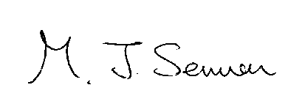 M Sermon, Clerk for Chairman

