EYE & DUNSDEN PARISH COUNCIL
A Meeting of the Council will be held on October 25th 2022 at Dunsden Village Hall commencing at 7.45pm.
- Apologies for absence
- Declarations of Interest
- Minutes of the Parish Council meeting held on Tuesday September 27th 2022
- Matters arising from the minutes
- County Councillor’s report
- District Councillor’s report
- Public Question Time/Correspondence
- Financial Position: a) Accounts b) October accounts for payment
- Planning Applications
New Applications:
P22/S3478/FUL Extension to existing building to create rehearsal room facility. The Mill at Sonning (Theatre) Sonning Eye RG4 6TY
P22/S3639/HH Erection of single storey annex to front of property, removal of existing outhouse/s at front of property. The Granary Foxhill Lane Playhatch RG4 9QA
Applications Granted
P21/S1844/LB Removal of existing tiles. Insulate with a multilayer insulation fabric (supplied SuperFoil Insulation Company reg: 3479247 which is breathable),and then retile. Rebuild the dormer windows frames in the roof with same materials. Single glazed. Custom made windows would replace rotten existing. Gully would be repaired or re-lead lined as original. The Homestead Road from The Homestead To Frizers Farm Sonning Eye RG4 6TN
Applications Refused:
P22/S1691/FUL Change of use of an established lake for recreation and sports purposes. Caversham Lake Watersports Henley Road Caversham RG4 9RA
Planning Issues: Moorings at Sonning, poplar felling
- Eye & Dunsden Village Hall
- Neighbourhood Development Plan update
- Community Orchard
- Highways, Footpaths & Paths signage in Sonning Eye & Dunsden; the Playhatch permissive path; Furleigh Car Park
- Allotments
- Website
- Minerals/Playhatch and Sonning pit liaison groups
- Matters for future consideration Budget for 2023; further pedestrian signage
Date of next meeting: Tuesday 15th November
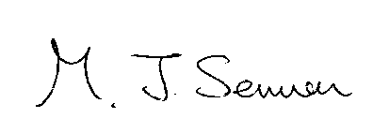 M Sermon, Clerk for Chairman

